Hi.

I haven’t decided on the name of the bot yet, so just pick a name for the developer to use for now. I will change it when I get the code.  
  
This strategy uses 3 indicators;

1. SuperTrend Indicator: It is very simple to understand. In additional to giving BUY and SELL signals. It also gives SL prices.

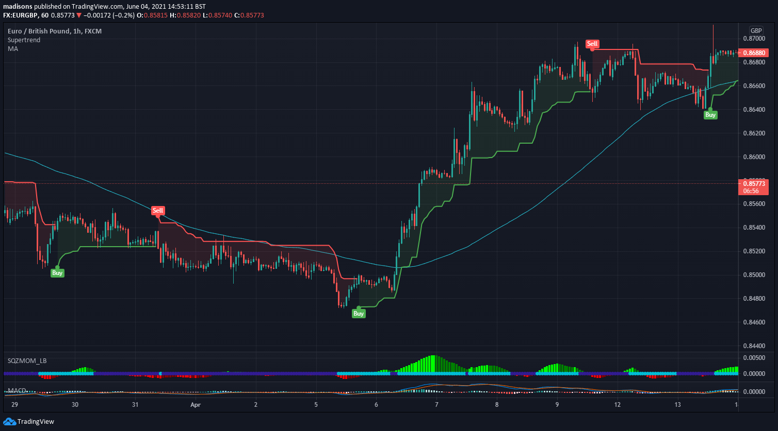

1. Squeeze Momentum Indicator: There are 3 parts of this indicator that are important to this strategy [It might look different from the default settings in TradingView. I change the color styling].
   1. The Green and Red Histogram: This part will determine the direction of the position (part of the Entry rule).
   2. The Light and Dark bars of the histogram: This part will be used as a TSL/BE trigger.
   3. The middle light and dark blue circles: These are also part of the entry rule, as well as the exit rule.

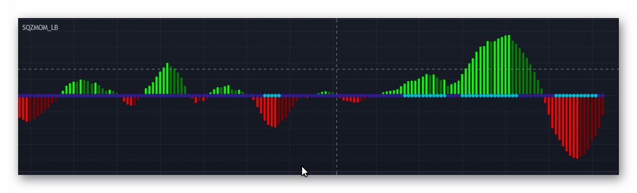

1. The MACD: This is also part of the entry rule. These are the specific rules for MACD.
   1. BUY: A Bullish Crossover (MACD over signal line) below zero
   2. SELL: A Bearish Crossover (MACD below signal line) above zero

The strategy also uses a Moving average to determine overall long-term trade direction.

**BUY ENTRY RULES:**

* SQUEEZE MOMENTUM: The first light blue circle after a series of dark blue circles; and the histogram is showing a green bar. The candle with the first light blue circle is the Signal candle.
* SUPERTREND: Showing a BUY signal (below price).
* MACD: The most recent crossover must be a BUY (according to how I described it earlier).
* MOVING AVERAGE: Signal candle is above Moving Average

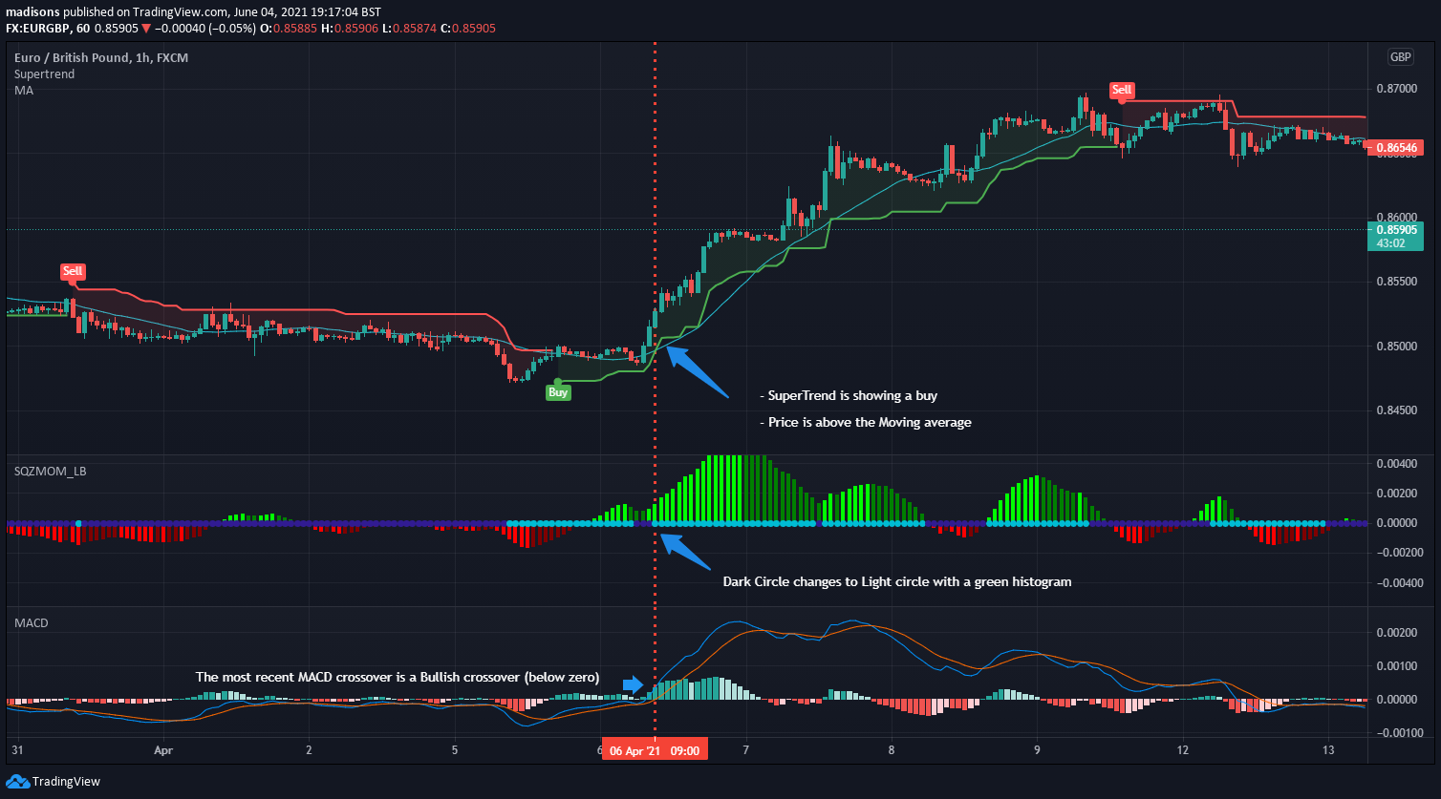

See the image above.

**SELL ENTRY RULES:**

* SQUEEZE MOMENTUM: The first light blue circle after a series of dark blue circles; and the histogram is showing a red bar. The candle with the first light blue circle is the Signal candle.
* SUPERTREND: Showing a SELL signal (Above price).
* MACD: The most recent crossover must be a SELL (according to how I described it earlier).
* MOVING AVERAGE: Signal candle is Below Moving Average

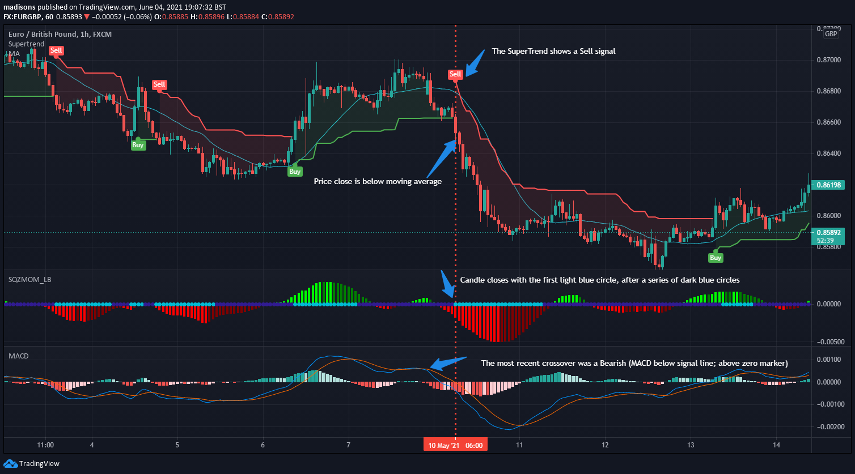

Some additional rules:

* There should only be one per scenario. If a position was closed manually by the user, the bot should not take another trade, until all the rules occur again in another scenario. I hope you understand. Sometimes, the user might close the trade to lock some profits, and all the rules might still be true then. In that case, the bot will wait for the rules to go false and true another time before entering again.
* The MACD rule has another alternative format; I would like you to add this as a parameter (so that I can choose what format the MACD rule should be). In the alternative format, every other indicator rule is the same, but the MACD will be as follows:
  + BUY: The most recent crossover is a Bullish crossover (MACD line above the signal line), but it doesn’t matter if the crossover occurred below the zero line or above it.
  + The same applies for the SELL position, but the crossover should be a Bearish crossover.
* The bot might open 2 or 3 trades based on how many Take Profits the user selects.

Please note that these rules will be confirmed when the candle closes. So, when all the rules are met, the bot will open a position in the next candle bar (the entry candle).

**STOP LOSS AND TAKE PROFIT**

For stop loss, the SuperTrend value of the entry candle will be the stop loss; as easy as that.

The Take Profit will be set at a ratio of the SL (Risk to Reward ratio). This is what I mean, if the user input 1.5 as Take Profit Ratio, and if the Stop Loss was 20 pips, the Take Profit will be set to 20 * 1.5 = 30 pips.

There should be parameters to enable TP2 and TP3. These TP will also be a ratio of the SL. This is how it would be set:

* MULTIPLE POSITION METHOD: The first method is to open multiple positions for each Take Profit. The user would be able to set the specific lot size for each TP2 and TP3. All these positions will have the same SL and will obey the Breakeven and Trailing Stop rules.

**EXIT RULE, TRAILING STOP AND BREAKEVEN**

The main exit rule is the middle circles of the Squeeze Momentum indicator. If the circles change rom Light blue to Dark blue, that is an exit; the bot should close the position.

Also, if the SuperTrend indicator gives an opposite signal during a position, that is also an exit signal. THE MACD DOES NOT GIVE ANY EXIT SIGNAL, PLEASE NOTE.

For the Trailing Stop, the SuperTrend line will also serve as the Trailing Stop method. It would not exactly be moving the Stop Loss; it should still remain where it is, but if price closes below the SuperTrend line, the bot should automatically close the position.

For Breakeven settings, the trigger should be when the Squeeze Momentum histogram starts drawing darker bars (Check the picture of the indicator to see what I mean). When this happens, the bot should move the Stop Loss through this specific method:

* There should be a parameter for how much of the Stop Loss distance should be reduced. For example, imagine the user inputs 50% and the stop loss was 20 pips; when the breakeven is triggered, the bot will reduce 50% of the stop loss (10 pips). The new SL price will be 10 pips away from the entry price.

If the user input 100%, when the breakeven is triggered, the bot will remove 100% of the Stop Loss and move it too breakeven.

Some additional features:

* I don’t know if you can add a power button to the bot, so I can turn it off or on manually.

Thanks all the features. There are some minor additions I am still working on (I would send to you later).  
  
Please let the developer know that I would like for the bot to be ready by Sunday evening, so I can have enough time to prepare my charts for the week. Thanks